Task 4.6

All in all, I found this to be an interesting task as I understand the importance of being able to monitor a page to increase user satisfaction and experience. I had some friends view my page as well with only positive feedback. I found Atatus very straight forward and easy to use which is definitely a tool that I will keep in mind for the future, should I be asked to monitor the performance of an application again.

The only error I encountered was the error when completing the lesson which I resolved by removing “atatus.notify(new Error(‘Test Atatus Setup’)” from my index.js file.

All page load times were less than 2 seconds:

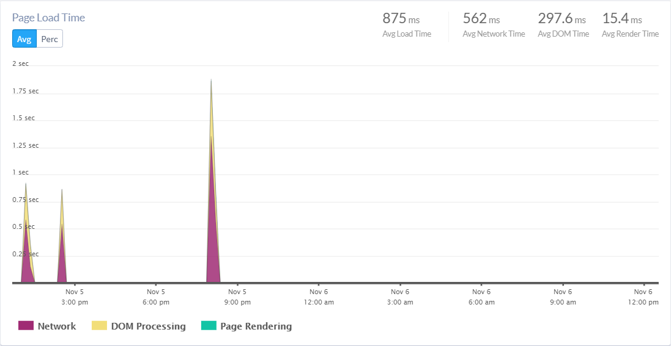

My Apdex shows 100% satisfaction:

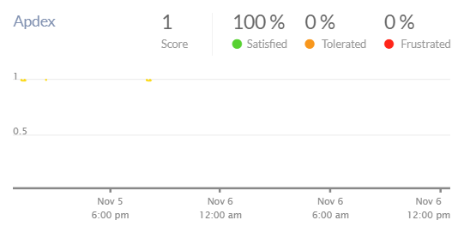

My Ajax response times are less than 1.5 seconds:

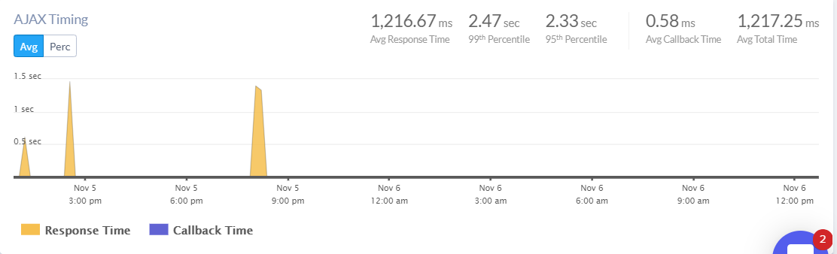

My app has been used by Safari and Chrome with page load time being under 1.5 seconds:

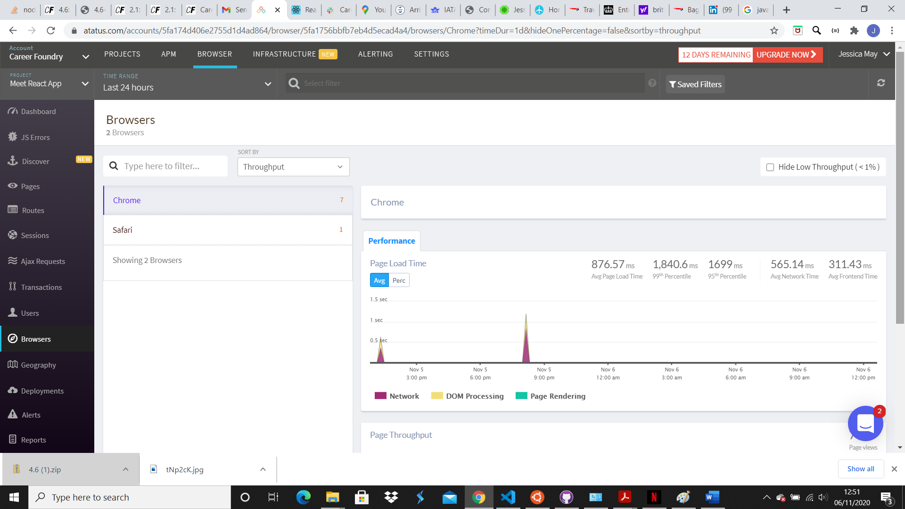

I have no further errors:

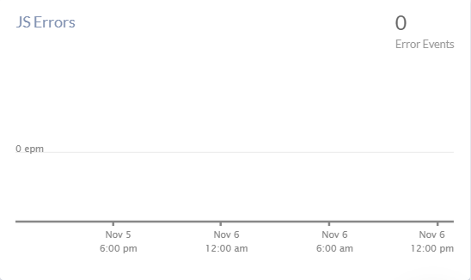

Screenshot of my dashboard:

